# **Assignment 01**

## 

## **Q1. What is software? What is software engineering?**

Software is a set of instructions, data or program used to operate computers and execute specific tasks. Software is a generic name used to refer application, scripts, programs that run on a device.

Software is an engineering based approach to software development. A software is a person who applies the engineering design process to design, develop, test, maintain, and evaluate computer software. Software engineering applies engineering principles & knowledge to programing language to built software solution for end users.

## **Q2. Explain types of software?**

Types of software are as follows:

1. Application Software
2. Middleware Software
3. System Software
4. Driver Software
5. Programming Software

**Application Software:**

It is a computer program designed to help people perform an activity.

**Middleware Software:**

Software that lies between an operating system and the applications running on it.

**System Software:**

A program designed to run a computer's hardware and applications and manage it's resources, such as memory, processors, and devices.

**Driver Software:**

It is a software component that lets the operating system and device communicate.

**Programming Software:**

A programming language which is a system of notation for writing computer programs. A computer programming is usually described in terms of its syntax and semantics

## **Q3. What is SDLC? Explain each phase of SDLC.**

The Software Development Life Cycle [SDLC] it is the cost efficient and time effective process that develop team use to design and build high quality software. The purpose of SDLC is to minimize project risks through forward planning so that software meets customer expectations during production and beyond.

The Software development lifecycle outlines several tasks required to build a software application. The development goes through several stages as developers and new features and fix bugs in the software.

Common SDLC phases:

1. Planning
2. Requirement & Analysis
3. Designing
4. Implementation or Coding
5. Testing
6. Deployment
7. Maintenance

**Planning**

In this stage you are gathering business requirements from your client or stakeholders. This phase is when you evaluate the feasibility of creating the product, revenue potential, cost of production, the need of end-user

**Requirement & Analysis**

The senior member of the team perform it with inputs from all the stakeholders and domain experts in the industry. Business Analysist and Project Organizer setups the meeting with the client to gather all the data like [i] what the customers want, [ii] Who will be the end user, [iii] What is the objective of the product

**Designing**

The implementation of design begins concreting writing codes. Developers have to follow the coding guidelines their management like [i] compiler, [ii] interpreters, [iii] debuggers, etc. are used to implement and develop the code.

**Testing**

After the code is generated, it is tested against the requirements to make sure that the products are solving the needs addressed and gathered during the requirement & analysis stage. During this stage, unit testing, integration testing, system testing, acceptance testing are done.

**Deployment**

Once the software is certified, and no errors are stated, then it is deployed. Then based on the assessment, the software may get released as it is or with suggested enhancement in the object segment.

**Maintenance**

Once when the client starts using the developed system, then the real issue comes up and requirements to solve from time to time.

## **Q4. What is DFD? Create DFD on Flipkart.**

A data flow diagram is a representation of data through a process or a system. The DFD also provides information about the output and input of each entity & process itself. It is used to analyze an existing system. Dataflow can range from simple, in depth or multi-level DFD's. This is Yourdon-Coad

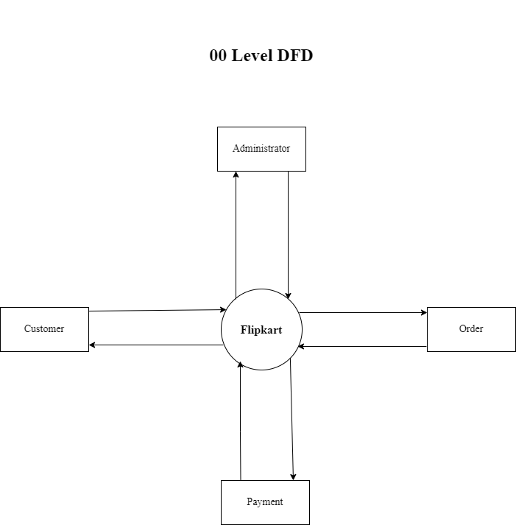

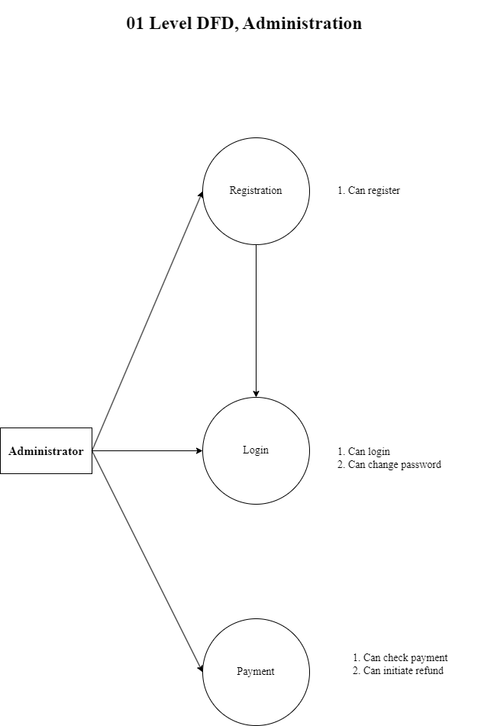

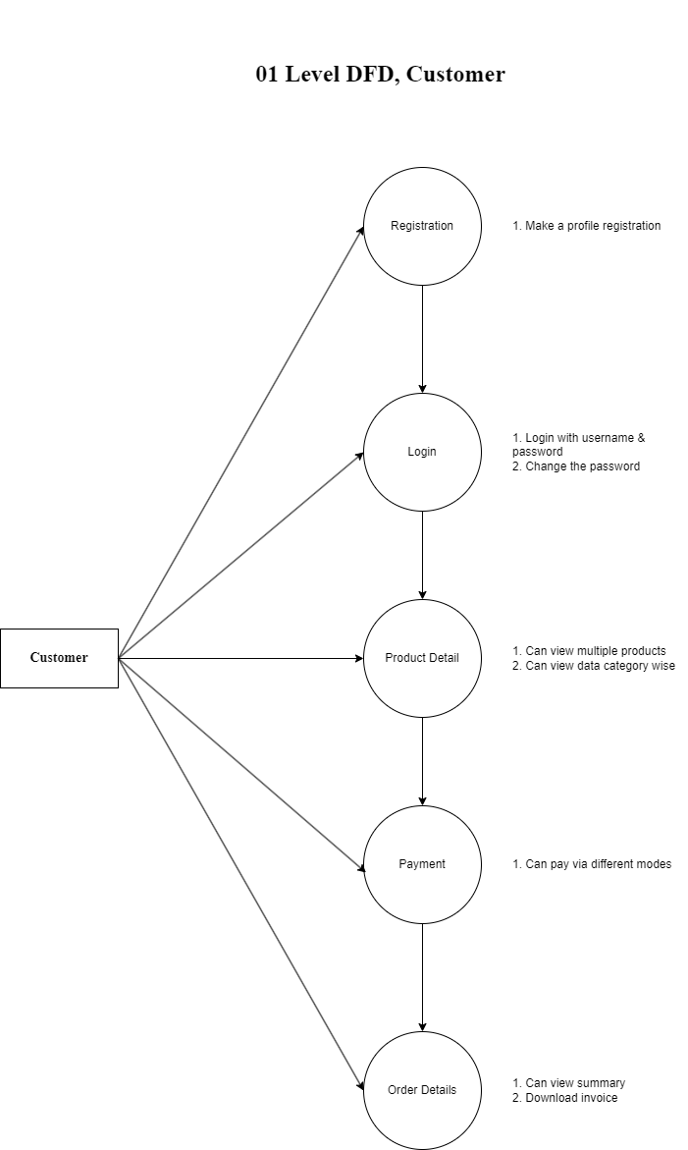

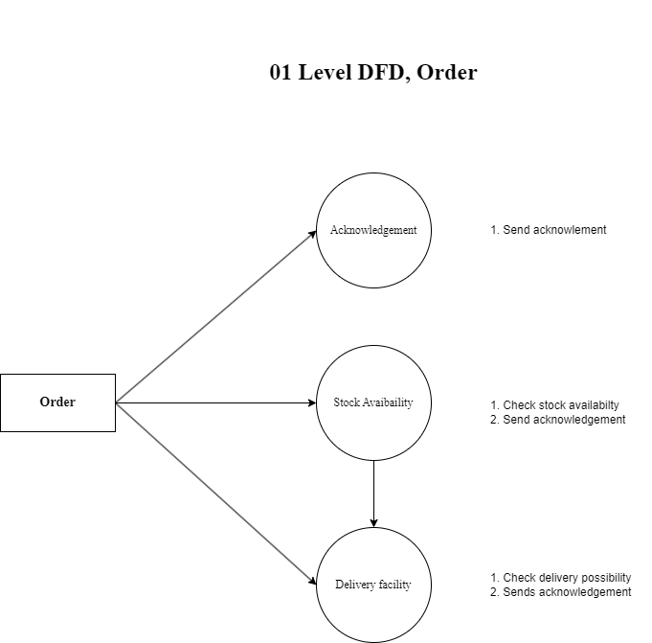

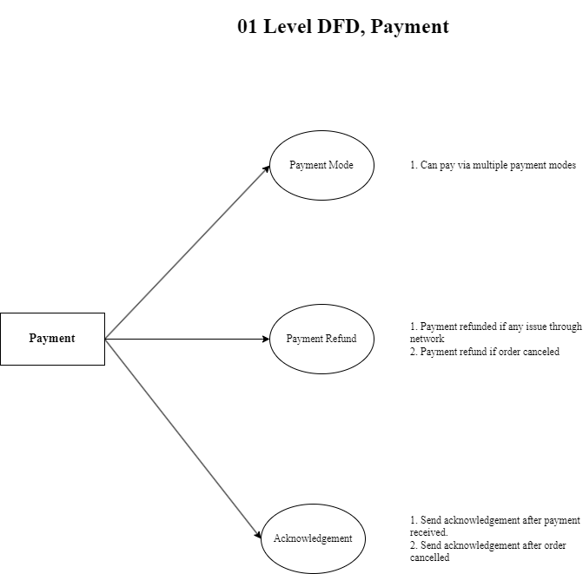

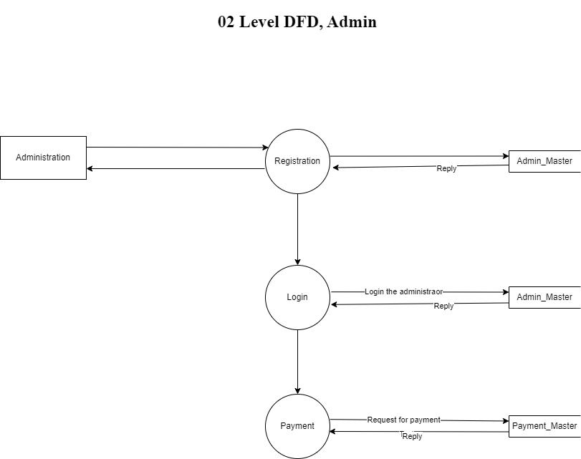

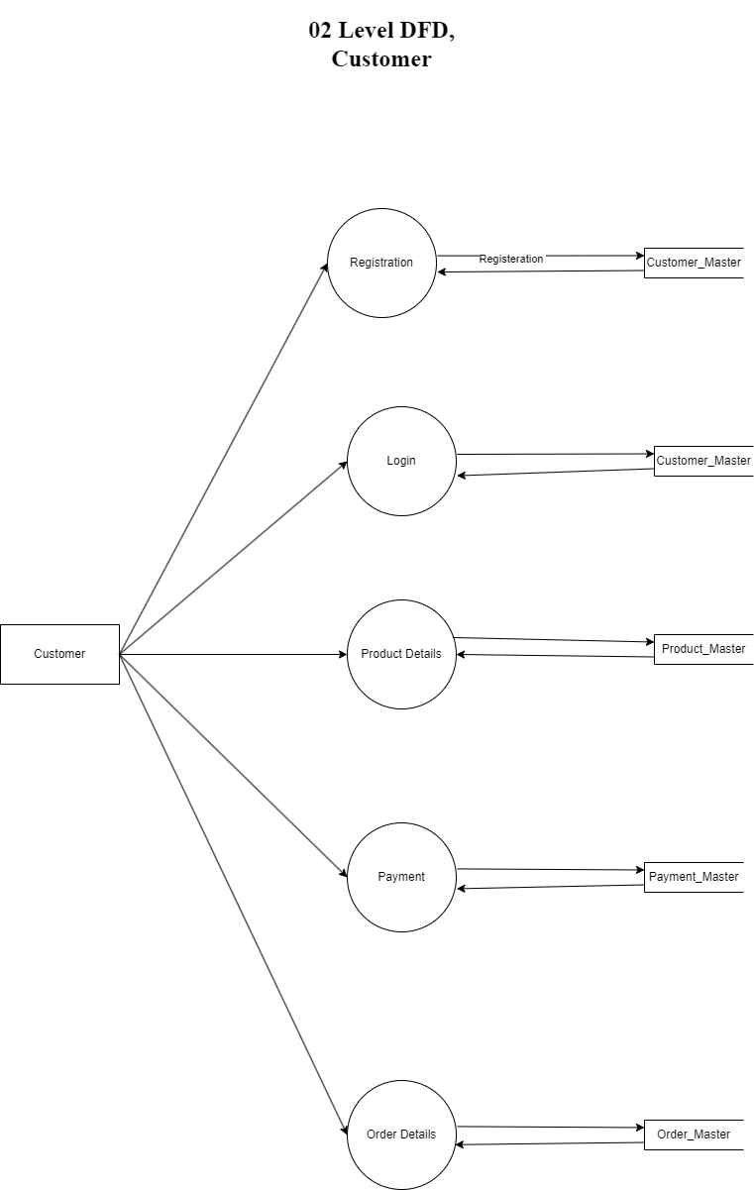

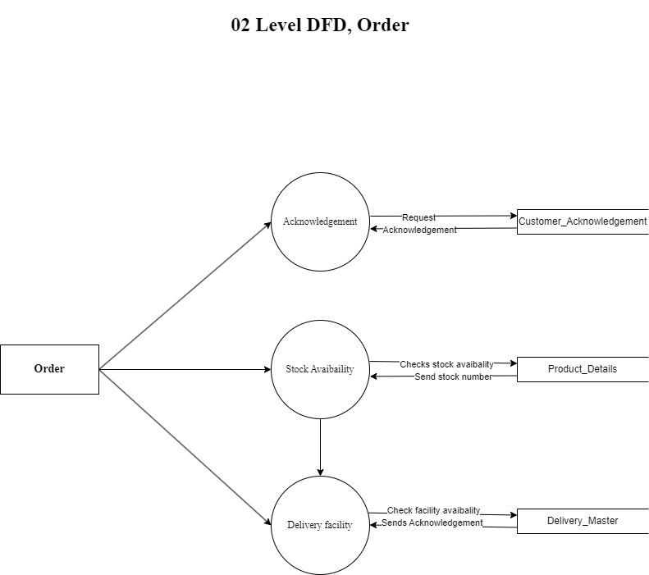

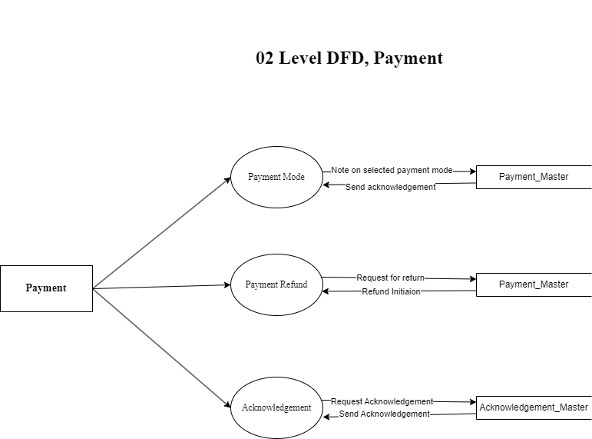

## 

## 

## 

## 

## 

## 

## 

## 

## 

## 

## 

## 

## 

## 

## 

## 

## 

## **Q5. What is Flow Chart? Create a flowchart to make addition of two numbers.**

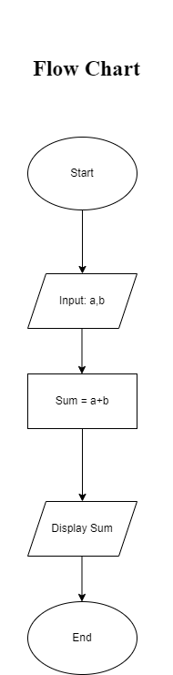

## **Q6. What is Use Case Diagram? Create a use-case on bill payment on payment.**

A Use Case diagram is a graphical depiction of a user's possible interaction with system. Use Case is specific sequence of interactions between an external actor and system that results in a measurable outcome.

